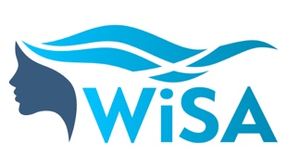 | MENTEE APPLICATION FORM
The WiSA 9-month mentoring programme is open to people who identify as female and who are currently either working in or studying aquaculture in Scotland.
Please tell us more about you below:
Full name
Email
Telephone number
Current occupation / area of study
Years of work / study in the aquaculture industry
Are you working or studying in this field at present?
Are you considering a career change?
What would you like to get from this programme?
What are your future career goals?
What do you want to achieve in one and five years from now?
What assistance / support do you need in order to achieve your short and / or long-term goals?
Please specify up to three personal development areas that you would like to focus on over the course of this program.
Please specify any barriers you may have faced whilst working or studying in this field.
Please also send a link to your up-to-date LinkedIn profile to accompany your application.
You must submit your application to wisa@sustainableaquaculture.com by 24 February 2023 to be eligible to join the March cohort.
Please make sure you have your line manager’s approval before applying to join this programme.

