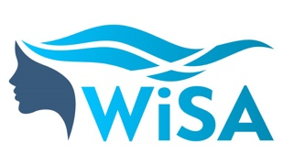 | MENTOR APPLICATION FORM
The WiSA 9-month mentoring programme is open to individuals who would like to mentor people who identify as female and are either working in or studying aquaculture in Scotland.
Please tell us more about you below:
Full name
Email
Telephone number
Current occupation
Current organisation
Duration spent working or studying in aquaculture (if applicable)
What skills could you bring to the mentor programme?
What barriers (if any) have you faced in your career which you could advise / support on?
Have you been a mentor previously?
If yes, please provide us with a short paragraph about this experience.
Please provide a few sentences about yourself / your career that we could share with mentees during the matching process.

Please also send a link to your up-to-date LinkedIn profile to accompany your application.
Please send your application to wisa@sustainableaquaculture.com by 24 February 2023 to be eligible to join the March cohort.

